If-Statement Exercises

goo.gl/aUipex

If you want example code to look at (similar to what was gone over today in class):

Examples:

<https://drive.google.com/file/d/0B7c0oBgP83iSSXBxN2t2ZEpBTkU/view>

Examples:

<https://drive.google.com/file/d/0B7c0oBgP83iSVkRnTzFUR09fZ3c/view>

Below are 15 practice problems. Do as many as you can. :)

*1. Same Name*

Have the user enter their first name. If the name is the same as yours, tell the user you have the same name. If not, tell them you have different names.

Example of 2 runs of the program:

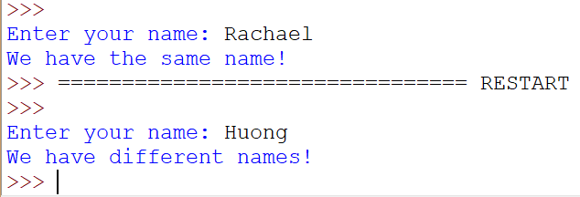

*2. Beach Trip*

Your parents will let you go to the beach with your friends if you have written 1500 or more words for your term paper. Write a program that asks the user how many words they have written and then prints out one of the two following messages, based on the result:

Great, you've done your homework. Enjoy the beach!

Sorry, you must stay home and work on your term paper.

Example of 2 runs of the program:

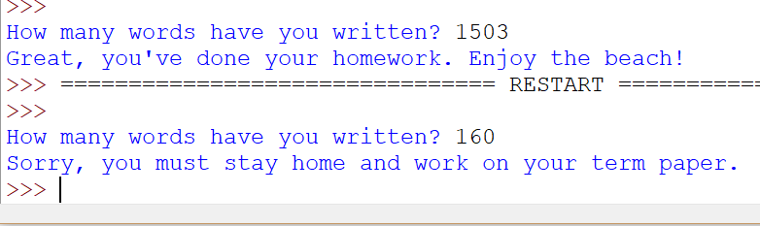

*3. Guess the Number*

Generate a random number between 1 and 10 inclusive, then have the user input a number to be their “guess.” If the numbers match, print out that the user won, if the guess was too low, print that it was too low, and if it was too high, print it was too high. With each output, print out what the random number was.

Example of 3 runs of the program:

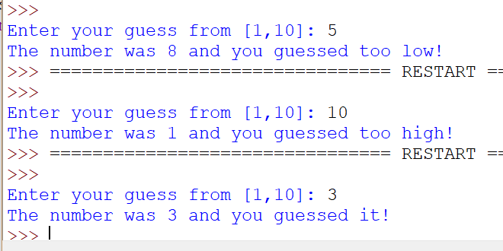

*4. Dice Competition*

Write a program that simulates a 2-player dice game by rolling a 20 sided die for each player. Generate the number on the die using the random number generator. Whichever player has the higher number wins (and if they have the same number, it’s a tie). Print out the number each player rolled and which player wins.

Example of 3 runs of the program:

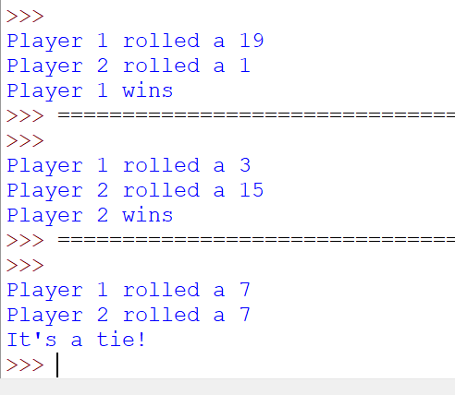

*5. Sometimes Sum*

Have the user enter a number in the range [1,100]. If the number is between 40 and 50, inclusive, then add 10 to the number and print out the new number. Otherwise, just print out their number.

Example of 2 runs of the program:

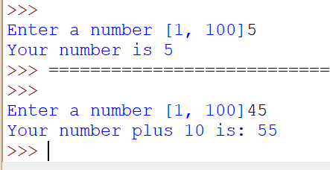

6. Even or Odd?

Have the user enter any number. Determine if their number is even (evenly divisible by 2) and print out whether it is even or odd.

Example of 2 runs of the program:

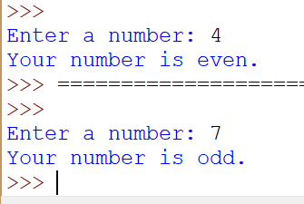

*7. Honors Diploma*

Students Qualify for the Honors Diploma if their GPA is 3.6 or higher, OR their SAT score is 1250 or higher. Write a program that asks the user for their GPA and SAT score and determines whether or not they qualify for the Honors Diploma.

Hint: Remember, if you want the user to be able to input decimals, cast the input method to float instead of int.

Example 3 runs of the program:

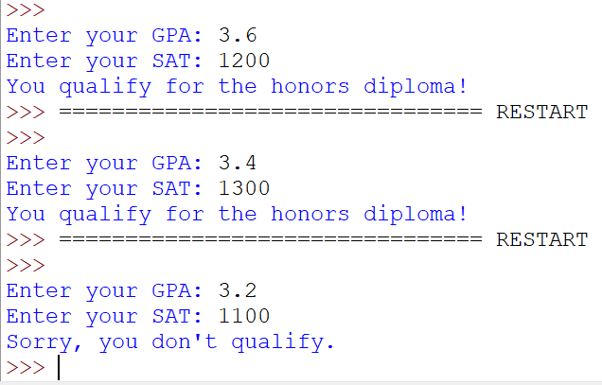

*8. Game Systems*

Let’s say your school awards you a game system depending on your grade point average (GPA). If your GPA is in between 3.0 and 3.5, inclusive, then you will get an XBOX One. If your GPA is greater than 3.5 but less than or equal to 3.8, you will get a PlayStation 4. If your GPA is greater than 3.8, you will get a Nintendo Switch. Write a program that prompts the user for their GPA and prints out which game system, if any, they will get.

Hint: Remember, if you want the user to be able to input decimals, cast the input method to float instead of int.

Example of 4 runs of the program:

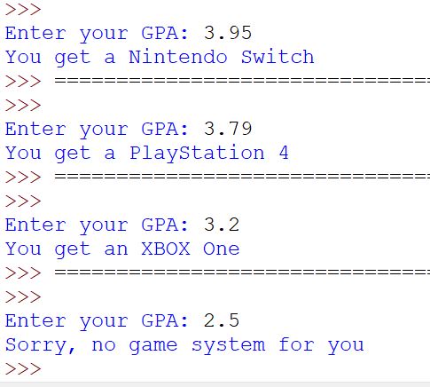

*9. Field Trip*

You only get to go on your field trip if you bring back a signed permission slip. If you get to go on the field trip, you get to choose between going to the history museum and the art museum. In your program, ask the user if they've brought back a signed permission slip. If they have, then ask them a history question (you can come up with your own question!). If they get it right, then tell them that they are going to the history museum. If they get it wrong, tell them they are going to the art museum. If the user doesn't bring back a signed permission slip, tell them they can't go on the field trip.

Example of 3 runs of the program:

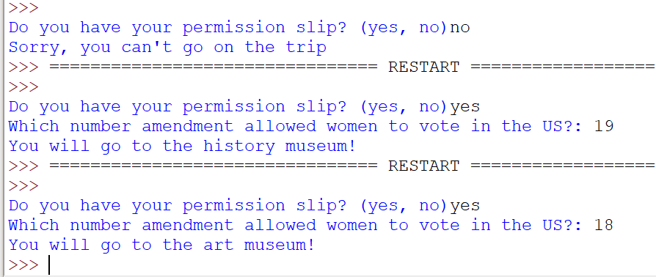

*10. Raking Leaves*

Your parents pay you $3 for each trash bag full of leaves you rake. If you can fill more than 10 bags in a month, they give you a bonus of $20. Write a program that asks the user how many bags of leaves they filled in the past month and prints out the total amount of money they made. For example, if someone fills 8 bags in a month, they would get $24. But, if they fill 11 bags in a month, they would get 11 x $3 + $20 = $53.

Example of 2 runs of the program:

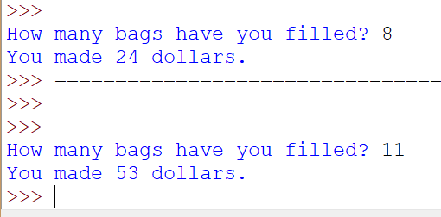

*11. Debbie’s Numbers*

Debbie likes numbers that have the same tens digit and units digit. For example, Debbie likes 133 and 812355, but she does not like 137 or 4. Write a program that asks the user for a number and then prints out whether or not Debbie likes the number.

Example of 4 runs of the program:

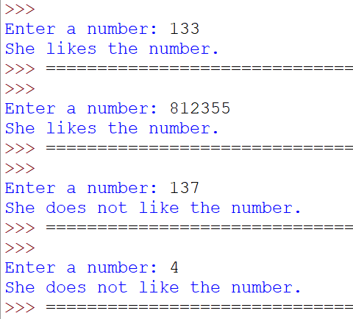

*12. Leap Years*

Leap years are always divisible by 4. But not every year divisible by 4 is a leap year. If the year is divisible by 100, but not divisible by 400, then it’s not a leap year.

1700 is divisible by 4. It’s also divisible by 100. But it’s not divisible by 400.

2016 is divisible by 4. It’s not divisible by 100, so we don’t have to check if it’s divisible by 400 or not..

Write a program to determine if a year that the user inputs is a leap year or not.

Example of 2 runs of the program:

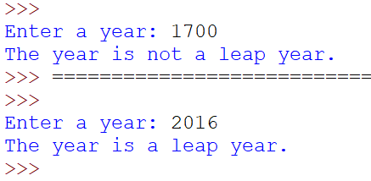

*13. Lots of ifs*

Write a program that gets a number from the user and then determines if a number is greater than 50 or less than or equal to 50. If, and only if, it is greater than 50, then determine if the number is even (evenly divisible by 2). If the number is less than or equal to 50, determine if the number is divisible by 3. Print out which one of the 4 cases it the number falls under, and then also print the number on a new line no matter what (see example below).

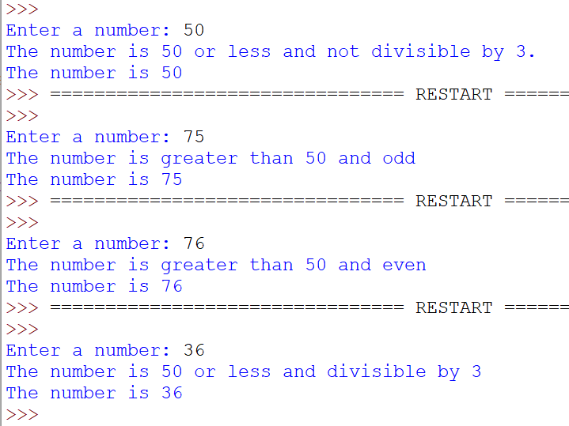

*14. Addition/Subtraction Quiz*

Start by asking the user if they want to do addition or subtraction. Have them input “add” for addition and “sub” for subtraction. Then give them either an addition or subtraction problem based on their answer. Use random numbers for the operands (I used range [1,9], but you can use another range). Have them input their solution to the problem and check if it’s correct. If so, print that out, and if not, print the correct answer. If they don’t enter “add” or “sub” for their operation, tell them they need to enter one of those words.

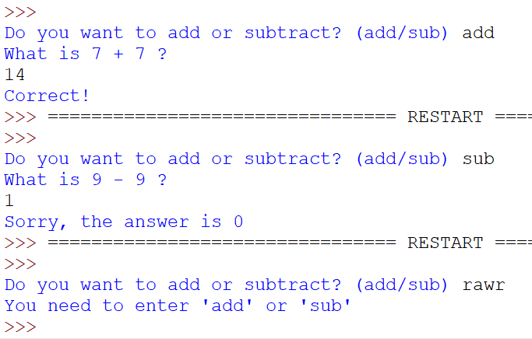

*15. Guessing game*

Write a guessing game for two players where both players guess a number in between 1 and a 100. The number they’re guessing should be generated randomly.

The winner is determined as follows: If both players guess the same number, the first player wins. If one player's guess is closer than the other player, then that player wins. If both players' guesses are off by the same value, then the player that guessed the lower number wins.

For example, if the secret number is 71 and the two players guesses are 64 and 77, then the player that guesses 77 wins, since 77 - 71 = 6 and 71 - 64 = 7. Alternatively, if the secret number is 45 and the two players guesses are 36 and 54, then the player that guesses 36 wins, since 45 - 36 = 9, 54 - 45 = 9, and 36 is less than 54.

Note: If you wish to get an absolute value of a number, import math and use the method math.fabs()

Example 3 runs of the program:

